International School


USER INTERFACE DESIGN DOCUMENT
Version: 1.3
HR DATA DASHBOARD PROJECT
Course: System Integration Practices
Semester: 2 – 2025-2026

Mentor: MSc. Nguyen Dang Quang Huy
Team Member:
Manh, Nguyen Van Duy
Loc, Tran Viet
Tin, Huynh Tran
Loi, Tran Van
Viet, Dang Dai

Da Nang, 21/04/2026
PROJECT INFORMATION
Project Acronym | HRD
Project Title | HR DATA DASHBOARD PROJECT
Start Date | 16 – March –2026 | End Date | 16 – May –2026
Lead Institution | International School, Duy Tan University
Role | Name | Email |  | Phone
Project Mentor | Nguyen Dang Quang Huy | huyndq@duytan.edu.vn |  | 0935525354
Team Members | Nguyen Van Duy Manh | duymanhdev@gmail.com |  | 0779534325
 | Tran Viet Loc | tranvietloc288@gmail.com |  | 0365957050
 | Huynh Tran Tin | trantin202ad@gmail.com |  | 0899565751
 | Tran Van Loi | tvl19012005@gmail.com |  | 0898238541
 | Dang Dai Viet | vdang9721@gmail.com |  | 0384165721

DOCUMENT INFORMATION
Document Title | User Interface Design Document
Reporting Period | 21 - April - 2026
Author(s) | Dang Dai Viet
Role | Developer
Date | 4/21/2026 | Filename | 7. UserInterface Design Document.docx

SIGNATURE
Document Approvals: The following signatures are required for approval of this document.
Mentor | Huy, Nguyen Dang Quang | Signature:
 |  | Date:
Project Manager | Manh, Nguyen Van Duy | Signature:
 |  | Date:
Team member(s) | Loc, Tran Viet | Signature:
 |  | Date:
 | Tin, Huynh Tran | Signature:
 |  | Date:
 | Loi, Tran Van | Signature:
 |  | Date:
 | Viet, Dang Dai | Signature:
 |  | Date:

REVISION HISTORY
Version | Date | Description
1.0 | 4/21/2026 | Create User Interface Design Document

TABLE OF CONTENTS
1. Introduction 7
1.1. Purpose 7
1.2. Scope. 7
1.3. Definitions, Acronyms, and Abbreviations. 7
1.4. References 8
2. List of User Interface 8
3. Describe User Interface 9
3.1. UI-01: Auth Page 9
3.1.1. Sub-Interface: Sign In (Login Form) 10
3.1.2. Sub-Interface: Create Account (Registration Form) 11
3.2. UI-02: Main Layout 12
3.2.1. Sub-Interface: Header (Contextual Actions) 12
3.2.2. Sub-Interface: Sidebar (Navigation & Status) 13
3.3. UI-03: Executive Dashboard 14
3.3.1. Main Dashboard Components 14
3.3.2. Sub-Section: Recent Activity Timeline 15
3.3.3. Sub-Section: Database Schema Overview 16
3.4. UI-04: Employee 360 17
3.4.1. Initial Search State 17
3.4.2. Unified Profile View (Result State) 18
3.5. UI-05: Reconciliation Center 19
3.6. UI-06: Actionable Reports 20
3.6.1. Sub-Interface: Employee Compensation Report 21
3.6.2. Sub-Interface: Department Payroll Report 22
3.6.3. Sub-Interface: Sync Exceptions Report 23
3.7. UI-07: Data Management 24
3.7.1. Sub-Interface: Employee Directory 26
3.7.2. Sub-Interface: Add / Edit Employee Modal 27
3.7.3. Sub-Interface: Payroll Records (Salaries Tab) 28
3.7.4. Sub-Interface: Add / Update Salary Modal 30
3.7.5. Sub-Interface: Attendance Records (Attendance Tab) 31
3.7.6. Sub-Interface: Departments (HR Sync) 32
3.7.7. Sub-Interface: Job Positions (HR Sync) 33
3.7.8. Sub-Interface: Dividend Distributions 33
3.8. UI-08: API Explorer 34
3.9. UI-09: Settings 36
3.10. UI-10: Account Management (Access Control) 37
3.10.1. Sub-Interface: Security Reset Modal 39
3.10.2. Sub-Interface: Role Update Modal 40

- Introduction

1.1. Purpose
- This document provides a detailed description of the User Interface (UI/UX) design for the integrated Dashboard system. The goal is to provide a visual overview of how users interact with human resource data (from HUMAN_2025) and payroll data (from payroll_2026) on a single unified platform.

1.2. Scope.
- This document focuses on the UI/UX design for Company X's integrated Dashboard, including:
- Static Mockups: Visual sketches for 17 functional screens, including the Dashboard, HR Management, Payroll Management, Attendance, Reports, and Alerts.
- Control Specifications: A list and explanation of the functions for every button, input field, chart, and data table on each screen.
- Display Data Integration: Ensuring the interfaces fully display data fields mapped from both HUMAN_2025 (SQL Server) and payroll_2026 (MySQL).
- User Interaction Flow: Description of how users navigate between pages and perform data synchronization tasks.
- Out of Scope:
- Source code implementation (coding) for the interface.
- Detailed database structure design or Backend (API) logic.
- System security configurations or network infrastructure.

1.3. Definitions, Acronyms, and Abbreviations.
Acronym/Term | Definition
HUMAN | Human Resource Management Database (SQL Server)
PAYROLL | Payroll Management Database (MySQL)
PK | Primary Key
FK | Foreign Key
ERD | Entity Relationship Diagram

1.4. References
- Case Study 1 – Problem Statements
- Software Requirement Specification (SRS) Document
- IEEE Std 1016-2009 – Standard for Software Design Descriptions
- CMU-CS445 Course Material, Duy Tan University (2025)
- List of User Interface
Roles | User Interface ID | UI Name | Description
All | UI-01 | Auth Page | User authentication page (Login & Register) to access the system securely.
All | UI-02 | Main Layout | Global navigation consisting of the Sidebar and Header for quick module switching.
Admin, Editor, Viewer | UI-03 | Executive Dashboard | Provides an overview of system integration health, database connection status, and activity timeline.
Admin, Editor, Viewer | UI-04 | Employee 360 | Search and view unified HR and Payroll profiles for individual employees across both databases.
Admin, Editor | UI-05 | Reconciliation Center | Detects and resolves cross-database anomalies (e.g., missing records in HR or Payroll).
Admin, Editor, Viewer | UI-06 | Actionable Reports | Generates and exports read-only cross-database analytical reports (Excel/PDF format).
Admin, Editor | UI-07 | Data Management | Centralized CRUD management interface for Employees, Salaries, Attendance, Departments, and Positions.
Admin, Developer | UI-08 | API Explorer | Interactive developer tool to test API endpoints and view live database schemas.
All | UI-09 | Settings | System configuration, UI theme preferences, and database diagnostic status.
Admin | UI-10 | Account Management | Manage system-wide user accounts, role-based access control (RBAC), and security resets.
Table 1: List of User Interface

3. Describe User Interface

3.1. UI-01: Auth Page
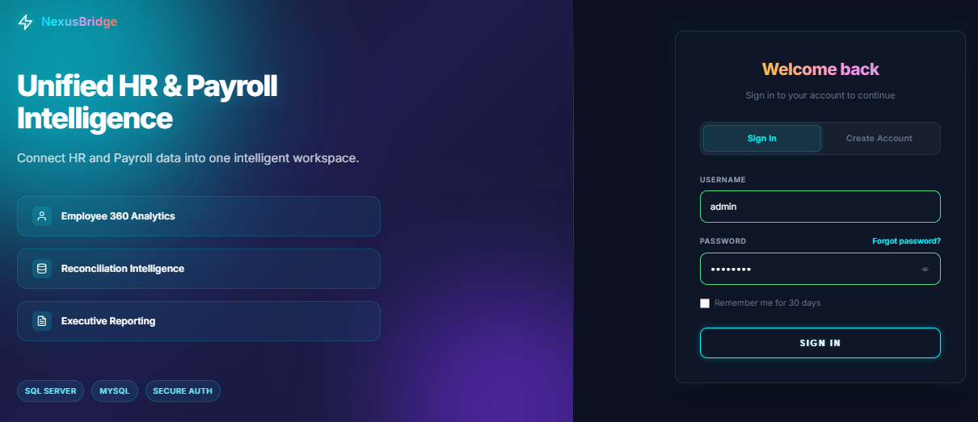
Figure 1: Auth Page
ID | Condition | Control Type | Target
1 | View | Logo & Text | Brand Identity: Displays the "NexusBridge" logo and the primary message "Unified HR & Payroll Intelligence".
2 | View | List Item | Feature Highlights: Highlights key modules: Employee 360 Analytics, Reconciliation Intelligence, and Executive Reporting.
3 | View | Badge | Tech Stack Badges: Labels indicating supported technologies: SQL Server, MySQL, and Secure Auth.
4 | Press | Tab Group | Auth Switcher: Toggle buttons to switch the right panel between "Sign In" and "Create Account" forms.
Table 2: Auth Page

3.1.1. Sub-Interface: Sign In (Login Form)
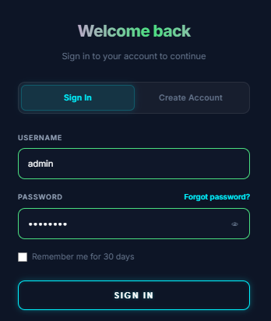
Figure 2: Sign In
ID | Condition | Control Type | Target
1 | Press | Input (Text) | Username: Field to enter the user's account name.
2 | Press | Input (Password) | Password: Secure input field for the user's password, equipped with an eye icon to toggle visibility.
3 | Press | Text Link | Forgot password: Link to trigger the simulated password recovery flow.
4 | Press | Checkbox | Remember me: Option to persist the authentication session for 30 days.
5 | Press | Button (Primary) | SIGN IN: Submits credentials to the /api/auth/login endpoint. Redirects to the Dashboard upon success.
Table 3: Sign In

3.1.2. Sub-Interface: Create Account (Registration Form)
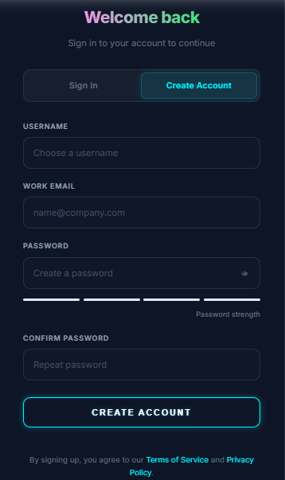
Figure 3: Create Account
ID | Condition | Control Type | Target
1 | Press | Input (Text) | USERNAME: Input field to choose a new account identifier.
2 | Press | Input (Email) | WORK EMAIL: Input field for a valid company email address.
3 | Press | Input (Password) | PASSWORD: Field for creating a new password, including a visibility toggle.
4 | View | Progress Bar | Password strength: A 4-segment dynamic bar evaluating password complexity.
5 | Press | Input (Password) | CONFIRM PASSWORD: Field to re-enter the password to ensure matching.
6 | Press | Button | CREATE ACCOUNT: Submits registration data to the API.
7 | Press | Text Link | Terms & Policy: Footer links directing users to the Terms of Service and Privacy Policy.
Table 4: Create Account

3.2. UI-02: Main Layout

3.2.1. Sub-Interface: Header (Contextual Actions)
Figure 4: Header
ID | Condition | Control Type | Target
1 | View | Text | Page Title & Subtitle: Automatically updates to reflect the current page (e.g., "Executive Dashboard").
2 | Press | Button | Refresh: Manually reloads the current application state and data.
3 | Press | Button | Logout: Clears authentication tokens from LocalStorage and redirects the user back to the Auth Page.
Table 5: Header

3.2.2. Sub-Interface: Sidebar (Navigation & Status)
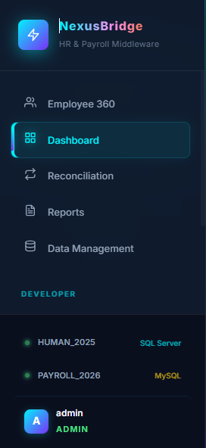
Figure 5: Sidebar
ID | Condition | Control Type | Target
1 | View | Logo & Icon | Brand Header: Displays the NexusBridge logo and "HR & Payroll Middleware" subtitle.
2 | Press | NavLink | Primary Navigation: List of core modules: Employee 360, Dashboard, Reconciliation, Reports, and Data Management.
3 | Press | NavLink | Developer & Admin Section: Access to API Explorer, Settings, and Account Management (Admin only).
4 | View | Status Dot | Database Health: Real-time connection indicators for HUMAN_2025 (SQL Server) and PAYROLL_2026 (MySQL).
5 | View | Profile Info | User Session: Displays the logged-in user's avatar (initial), username, and assigned Role (Admin/Editor/Viewer).
Table 6: Sidebar

3.3. UI-03: Executive Dashboard

3.3.1. Main Dashboard Components
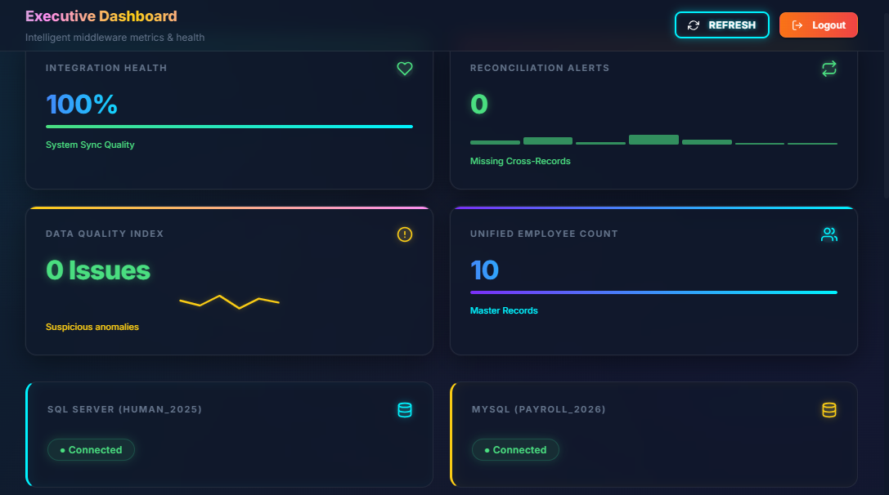
Figure 6: Main Dashboard Components
ID | Condition | Control Type | Target
1 | View | Stat Cards | KPI Overview: Four primary metrics: Integration Health (%), Reconciliation Alerts (count), Data Quality Index (issues), and Unified Employee Count.
2 | View | Progress Bar | Health Score: A dynamic visual indicator showing the overall quality and consistency of data synchronization.
3 | View | Sparkline | Data Anomalies: A visual trend line representing suspicious data patterns or salary anomalies detected by the middleware.
4 | View | Status Badge | Database Connectivity: Live indicators showing the "Online/Offline" status for both SQL Server (HUMAN_2025) and MySQL (PAYROLL_2026).
Table 7: Main Dashboard Component

3.3.2. Sub-Section: Recent Activity Timeline
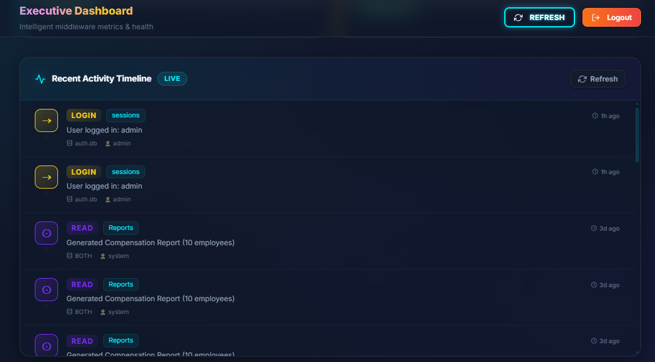
Figure 7: Recent Activity Timeline
ID | Condition | Control Type | Target
1 | Press | Button | Refresh Logs: Manually triggers a re-fetch of the latest audit entries from the API.
2 | View | Icon & Color | Action Indicators: Color-coded icons representing the type of operation.
3 | View | Text | Audit Details: Displays the table affected, the specific action taken, the timestamp (relative time), and the performing user.
Table 8: Recent Activity Timeline

3.3.3. Sub-Section: Database Schema Overview
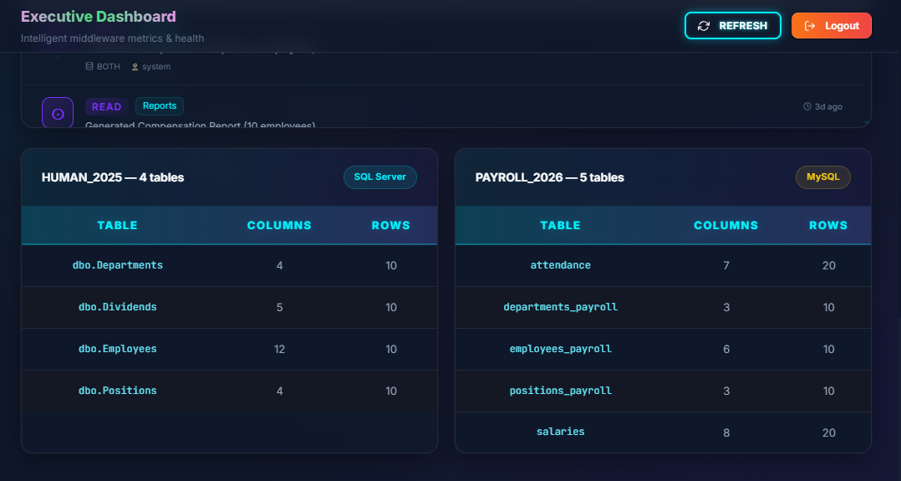
Figure 8: Database Schema Overview
ID | Condition | Control Type | Target
1 | View | Data Table | Schema Discovery: Lists the first tables discovered in each database along with their respective column and row counts.
2 | View | Badge | Engine Tag: Identifies the database engine type (e.g., "SQL Server" or "MySQL") for each connection.
Table 9: Database Schema Overview

3.4. UI-04: Employee 360

3.4.1. Initial Search State
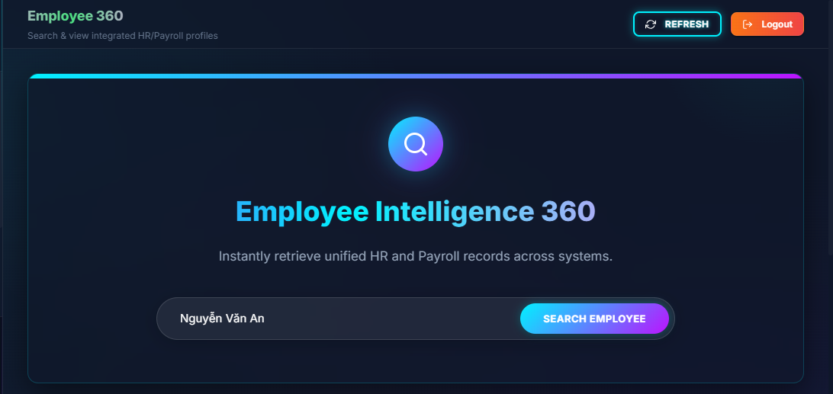
Figure 9: Initial Search State
ID | Condition | Control Type | Target
1 | View | Icon & Text | Hero Section: Displays a magnifying glass icon, the title "Employee Intelligence 360," and a descriptive subtitle.
2 | Press | Input (Text) | Search Bar: A centered input field to enter the employee's name or identifier.
3 | Press | Button (Primary) | SEARCH EMPLOYEE: Triggers the cross-database query to fetch matching records.
4 | Press | Button | Header Actions: "REFRESH" button to reload the page state and "Logout" button.
Table 10: Initial Search State

3.4.2. Unified Profile View (Result State)
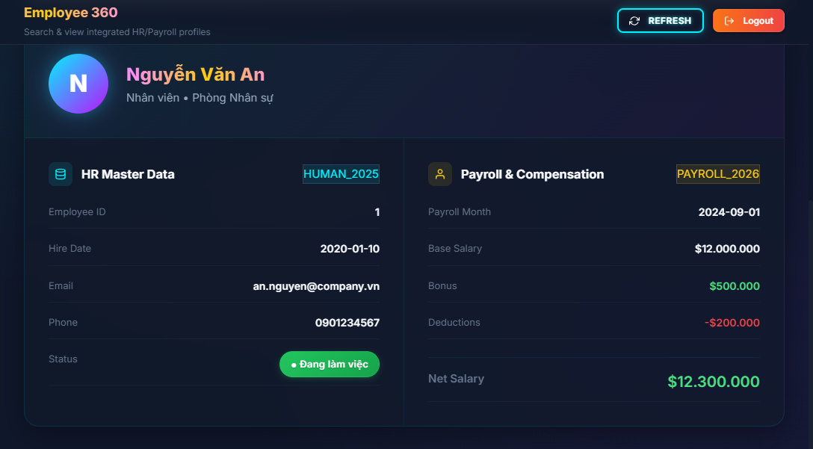
Figure 10: Unified Profile View
ID | Condition | Control Type | Target
1 | View | Profile Header | Identity Summary: Displays the employee's initial avatar, Full Name, Position, and Department.
2 | View | Data Panel (Left) | HR Master Data: Contains data exclusively from HUMAN_2025. Fields include: Employee ID, Hire Date, Email, Phone, and a color-coded Status badge.
3 | View | Data Panel (Right) | Payroll & Compensation: Contains data exclusively from PAYROLL_2026. Fields include: Payroll Month, Base Salary, Bonus (Green), Deductions (Red), and a prominently displayed Net Salary.
Table 11: Unified Profile View

3.5. UI-05: Reconciliation Center
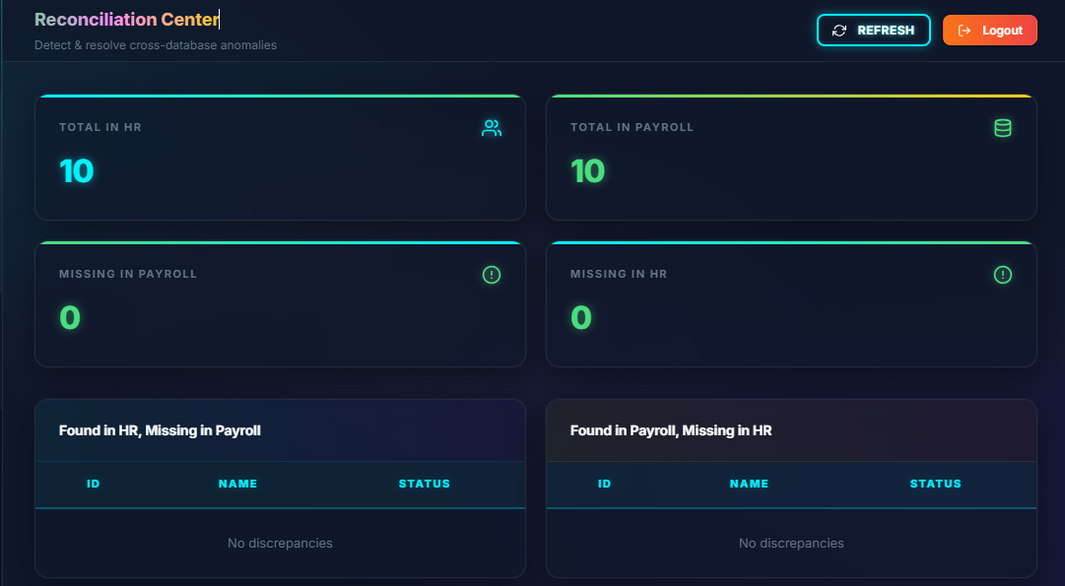
Figure 11: Reconciliation Center
ID | Condition | Control Type | Target
1 | View | Text & Buttons | Page Header: Displays the title "Reconciliation Center" along with "REFRESH" and "Logout" buttons.
2 | View | Stat Card | TOTAL IN HR: Displays the total count of employee records found in the HUMAN_2025 database.
3 | View | Stat Card | TOTAL IN PAYROLL: Displays the total count of employee records found in the PAYROLL_2026 database.
4 | View | Stat Card | MISSING IN PAYROLL: Highlighted metric showing records present in HR but missing in the Payroll system.
5 | View | Stat Card | MISSING IN HR: Highlighted metric showing records present in Payroll but missing in the HR master system.
6 | View | Data Table | Found in HR, Missing in Payroll: Detailed grid listing ID, NAME, and STATUS of records that failed to sync to MySQL.
7 | View | Data Table | Found in Payroll, Missing in HR: Detailed grid listing ID, NAME, and STATUS of orphan records found in MySQL.
8 | View | Text | Empty State: Displays "No discrepancies" within the grids when the databases are fully synchronized.
Table 12: Reconciliation Center

3.6. UI-06: Actionable Reports
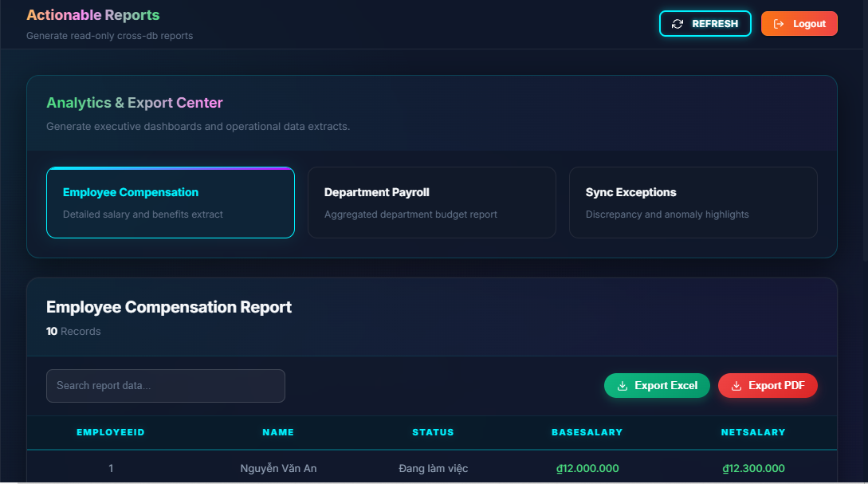
Figure 12: Actionable Reports
ID | Condition | Control Type | Target
1 | View | Text & Buttons | Page Header: Displays the title "Actionable Reports" alongside "REFRESH" and "Logout" buttons.
2 | View | Section Title | Analytics & Export Center: The container holding the three selectable report category cards.
3 | Press | Input (Text) | Search Bar: A global search input ("Search report data...") to filter the currently active dataset.
4 | Press | Button (Action) | Export Excel: A green button to download the active report dataset as an Excel (.xlsx) file.
5 | Press | Button (Action) | Export PDF: A red button to download the active report dataset as a formatted PDF document.
Table 13: Actionable Reports

3.6.1. Sub-Interface: Employee Compensation Report
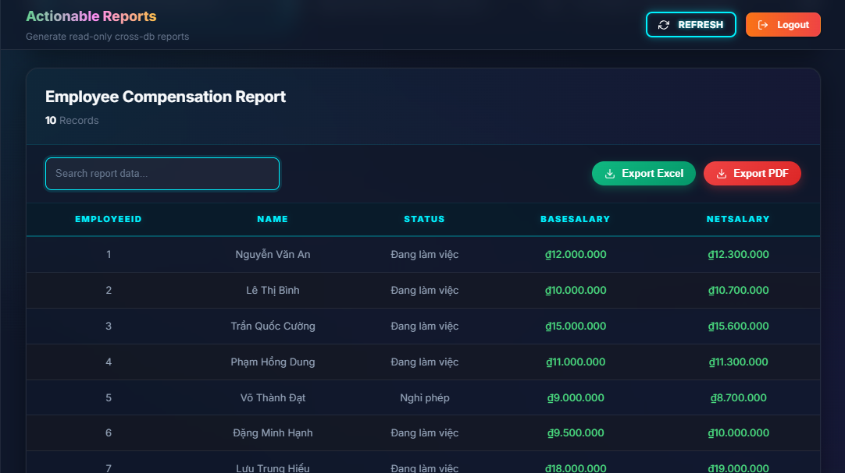
Figure 13: Employee Compensation Report
ID | Condition | Control Type | Target
1 | Press | Selectable Card | Report Tab: Card titled "Employee Compensation" with the description "Detailed salary and benefits extract". Displays a highlighted gradient border when active.
2 | View | Text | Report Header: Displays "Employee Compensation Report" and the total count of fetched records.
3 | View | Data Grid | Data Table: Displays the cross-database records with columns: EMPLOYEEID, NAME, STATUS, BASESALARY, and NETSALARY.
Table 14: Employee Compensation Report

3.6.2. Sub-Interface: Department Payroll Report
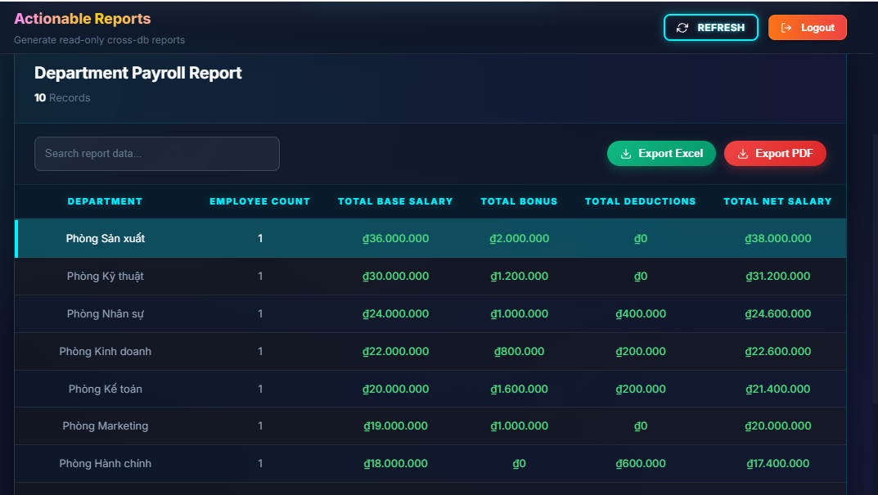
Figure 14: Department Payroll Report
ID | Condition | Control Type | Target
1 | Press | Selectable Card | Report Tab: Card titled "Department Payroll" with the description "Aggregated department budget report".
2 | View | Text | Report Header: Dynamically updates to "Department Payroll Report" and shows the record count.
3 | View | Data Grid | Data Table: Displays aggregated metrics. Expected columns include Department Name, Total Employees, Total Base Salary, and Total Net Payroll.
Table 15: Department Payroll Report

3.6.3. Sub-Interface: Sync Exceptions Report
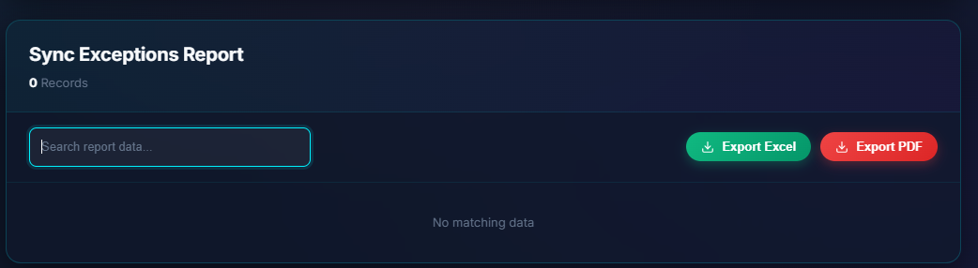
Figure 15: Sync Exceptions Report
ID | Condition | Control Type | Target
1 | Press | Selectable Card | Report Tab: Card titled "Sync Exceptions" with the description "Discrepancy and anomaly highlights".
2 | View | Text | Report Header: Dynamically updates to "Sync Exceptions Report" and shows the issue count.
3 | View | Data Grid | Data Table: Displays the anomaly records. Expected columns include Record ID, Source DB, Issue Type (e.g., Missing Data, Unmatched ID), and Status.
Table 16: Sync Exceptions Report

3.7. UI-07: Data Management
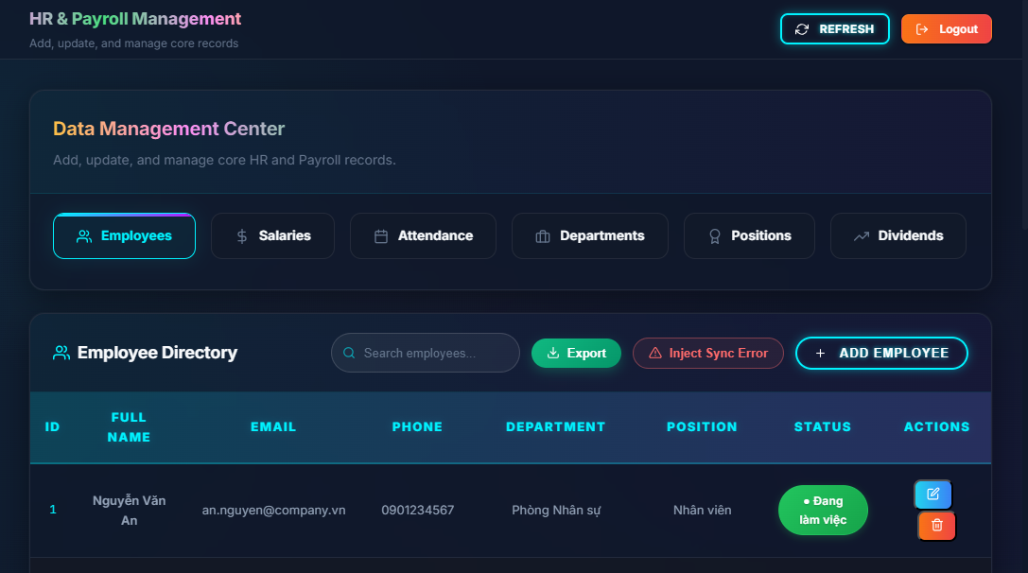
Figure 16: Data Management
ID | Condition | Control Type | Target
1 | View | Text & Buttons | Page Header: Displays the top-level title "HR & Payroll Management", a subtitle, and global "REFRESH" and "Logout" buttons.
2 | View | Section Panel | Data Management Center: The upper container grouping the entity navigation controls.
3 | Press | Tab Group | Entity Navigation: Six selectable tabs (Employees, Salaries, Attendance, Departments, Positions, Dividends) used to switch the active management context. The active tab is highlighted with a gradient border.
4 | View | Section Title | Dynamic Panel Header: Displays the title of the currently active entity (e.g., "Employee Directory") alongside its specific icon.
5 | Press | Input (Text) | Search Bar: A context-aware search input field (e.g., "Search employees...") to filter the records in the active grid.
6 | Press | Button Group | Global Actions: Primary action buttons relevant to the active tab, including a green "Export" button, a red-outlined "Inject Sync Error" button (for admin testing), and a highlighted "ADD" button (e.g., "ADD EMPLOYEE").
7 | View | Data Grid | Dynamic Data Table: The main table rendering the records for the selected entity, featuring sortable column headers.
8 | Press | Action Icons | Row Actions: Inline buttons on each table row (Blue Edit icon, Orange Delete icon) to perform CRUD operations on specific records.
Table 17: Data Management

3.7.1. Sub-Interface: Employee Directory
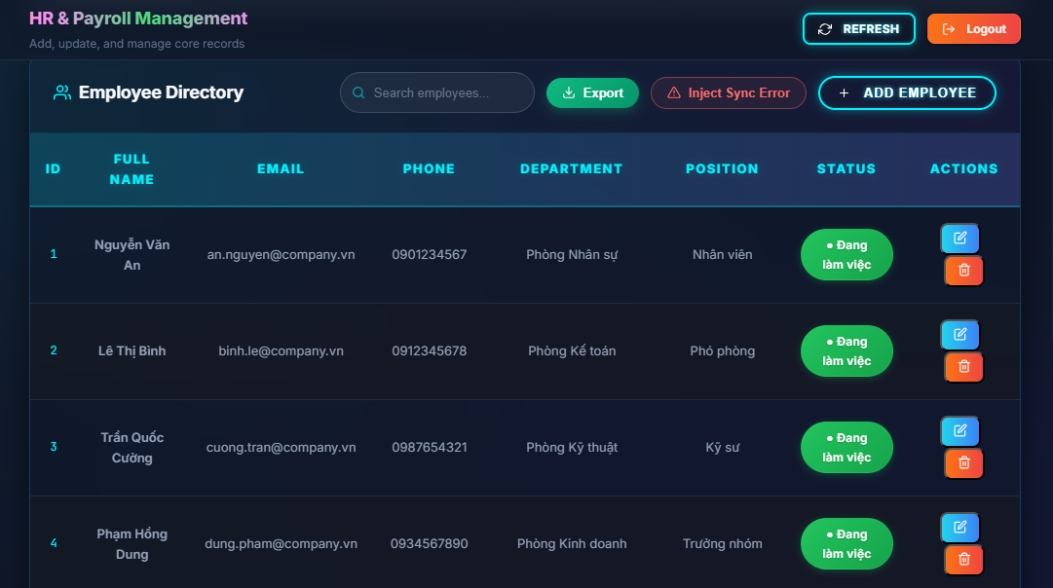
Figure 17: Employee Directory
ID | Condition | Control Type | Target
1 | View | Section Title | Panel Header: Displays the title "Employee Directory" alongside a user icon.
2 | Press | Input (Text) | Search Bar: Input field with placeholder "Search employees..." to filter the dataset.
3 | Press | Button (Action) | Export: Green button to download the current employee list.
4 | Press | Button (Action) | Inject Sync Error: Red-outlined button used by administrators to deliberately create a data anomaly for testing reconciliation.
5 | Press | Button (Primary) | ADD EMPLOYEE: Cyan-outlined button that triggers the "New Employee" modal.
6 | View | Data Grid | Employee Table: Displays core HR data. Columns include ID, FULL NAME, EMAIL, PHONE, DEPARTMENT, POSITION, and STATUS.
7 | View | Status Badge | Status Indicator: A color-coded pill badge (e.g., Green for "Đang làm việc") reflecting the employment state.
8 | Press | Action Icons | Row Controls: A blue Edit button (pen icon) to open the Edit modal, and an orange Delete button (trash icon) to remove the record.
Table 18: Employee Directory

3.7.2. Sub-Interface: Add / Edit Employee Modal
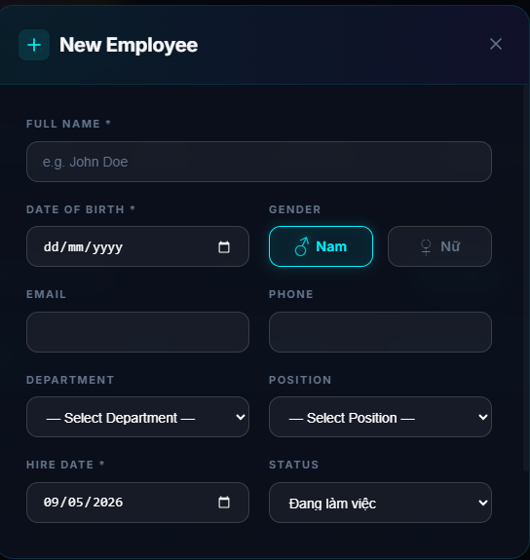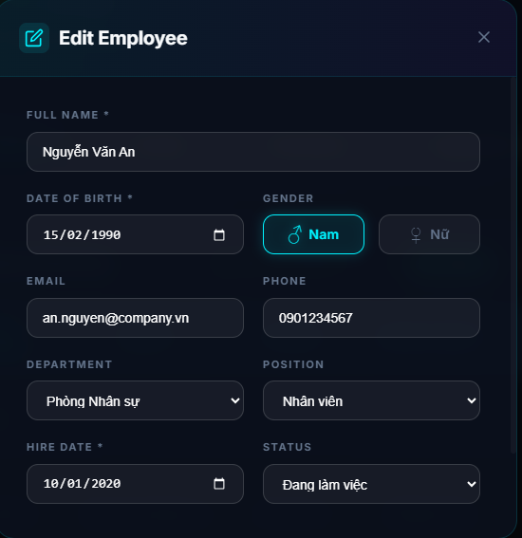
Figure 18: Add / Edit Employee Modal
ID | Condition | Control Type | Target
1 | View | Text & Icon | Modal Header: Displays "New Employee" for creation or "Edit Employee" for modification, along with a close (x) button in the top right corner.
2 | Press | Input (Text) | *FULL NAME: Mandatory field for the employee's full legal name.
3 | Press | Input (Date) | *DATE OF BIRTH: Mandatory date picker for the employee's birthday.
4 | Press | Button Group | GENDER: Toggle selection between "Nam" (Male) and "Nữ" (Female). The active choice is highlighted with a cyan border.
5 | Press | Input (Email) | EMAIL: Text input for the employee's work or personal email address.
6 | Press | Input (Tel) | PHONE: Text input for the employee's contact number.
7 | Press | Select Dropdown | DEPARTMENT: Dropdown menu to assign the employee to a specific organizational unit.
8 | Press | Select Dropdown | POSITION: Dropdown menu to define the employee's job title or role.
9 | Press | Input (Date) | *HIRE DATE: Mandatory date picker recording the employee's start date.
10 | Press | Select Dropdown | STATUS: Dropdown menu to set the current employment state (e.g., "Đang làm việc").
Table 19: Add / Edit Employee Modal

3.7.3. Sub-Interface: Payroll Records (Salaries Tab)
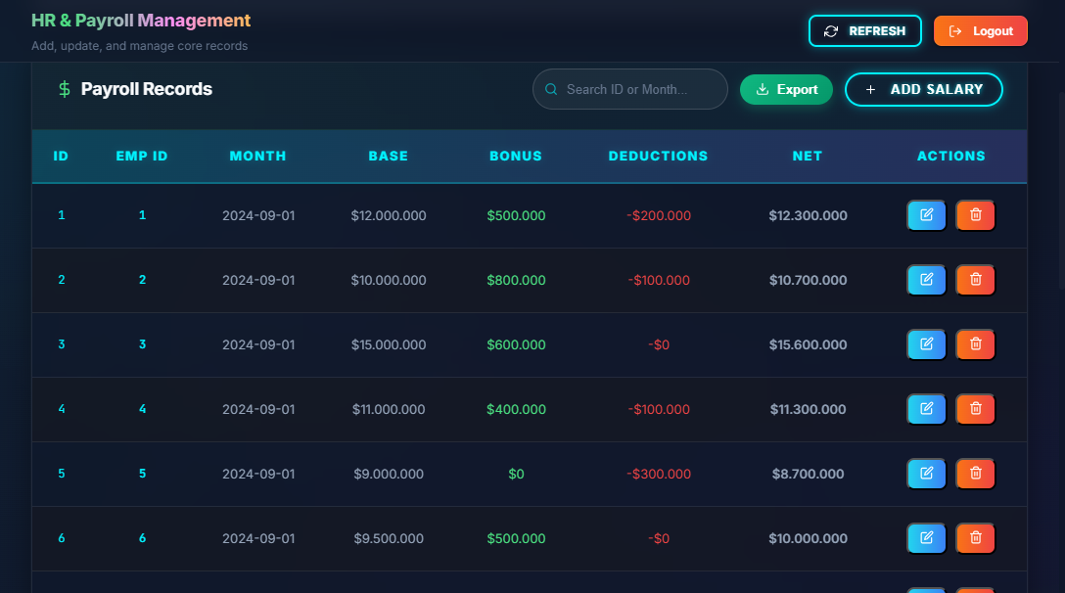
Figure 19: Payroll Records
ID | Condition | Control Type | Target
1 | View | Section Title | Panel Header: Displays the title "Payroll Records" alongside a green dollar sign icon.
2 | Press | Input (Text) | Search Bar: Input field with the placeholder "Search ID or Month..." to filter the payroll dataset.
3 | Press | Button (Action) | Export: Green button to download the current payroll records.
4 | Press | Button (Primary) | ADD SALARY: Cyan-outlined button that triggers the "Add Salary" modal.
5 | View | Data Grid | Payroll Table: Displays financial data. Columns include ID, EMP ID, MONTH, BASE, BONUS, DEDUCTIONS, and NET.
6 | View | Text (Colored) | Value Highlighting: Financial values are color-coded for quick scanning: Bonus amounts are green, and Deductions are red with a negative sign.
7 | Press | Action Icons | Row Controls: A blue Edit button to open the Update modal, and an orange Delete button to remove the specific payroll record.
Table 20: Payroll Records

3.7.4. Sub-Interface: Add / Update Salary Modal
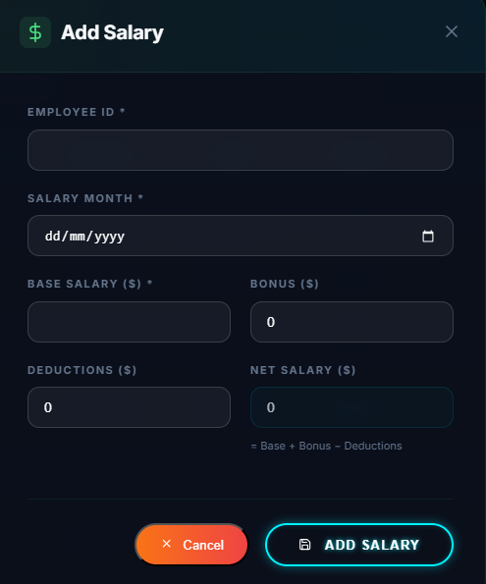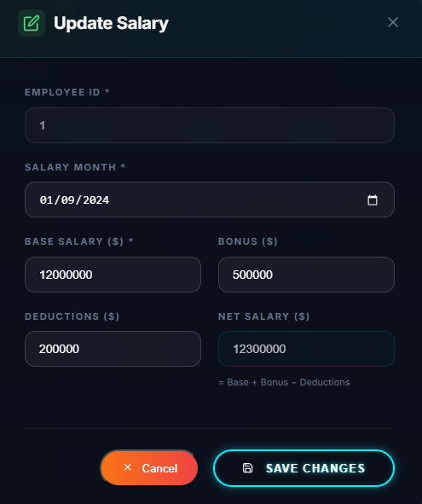
Figure 20: Add / Update Salary Modal
ID | Condition | Control Type | Target
1 | View | Text & Icon | Modal Header: Displays "Add Salary" or "Update Salary" with a respective icon and a close (x) button.
2 | Press | Input (Text) | *EMPLOYEE ID: Mandatory field linking the salary record to a specific employee.
3 | Press | Input (Date) | *SALARY MONTH: Mandatory date picker to define the specific payroll cycle (e.g., 01/09/2024).
4 | Press | Input (Number) | *BASE SALARY ($): Mandatory input for the employee's standard contractual pay.
5 | Press | Input (Number) | BONUS ($): Optional input for additional compensation or rewards.
6 | Press | Input (Number) | DEDUCTIONS ($): Optional input for penalties, taxes, or insurance subtractions.
7 | View | Input (Read-only) | NET SALARY ($): Displays the final calculated amount. A helper text below confirms the formula: "= Base + Bonus - Deductions".
8 | Press | Button (Action) | Cancel: Orange button to discard changes and close the modal.
9 | Press | Button (Primary) | Submit Action: "ADD SALARY" or "SAVE CHANGES" button to commit the data to the database.
Table 21: Add / Update Salary Modal

3.7.5. Sub-Interface: Attendance Records (Attendance Tab)
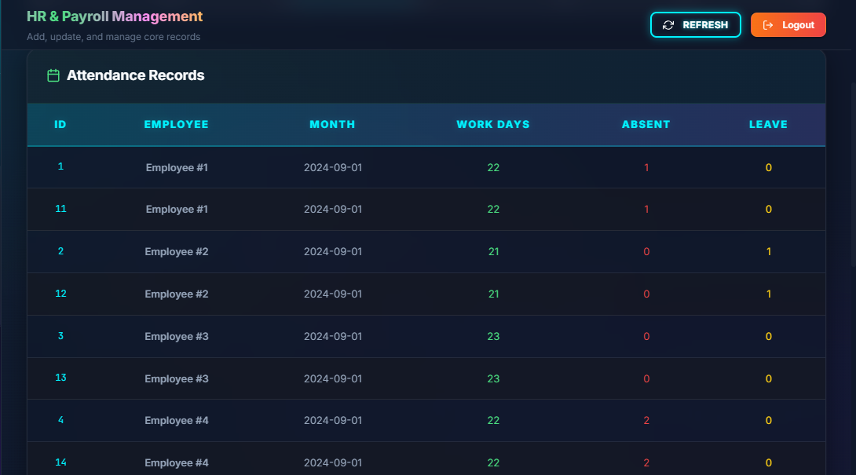
Figure 21: Attendance Records
ID | Condition | Control Type | Target
1 | View | Section Title | Panel Header: Displays the title "Attendance Records" alongside a green calendar icon.
2 | View | Data Grid | Attendance Table: A comprehensive grid displaying timekeeping metrics. Columns include ID, EMPLOYEE, MONTH, WORK DAYS, ABSENT, and LEAVE.
3 | View | Text (Colored) | Metric Highlighting: Key attendance numbers are color-coded for quick visual assessment: WORK DAYS are highlighted in green, ABSENT days in red, and LEAVE days in yellow/orange.
Table 22: Attendance Records

3.7.6. Sub-Interface: Departments (HR Sync)
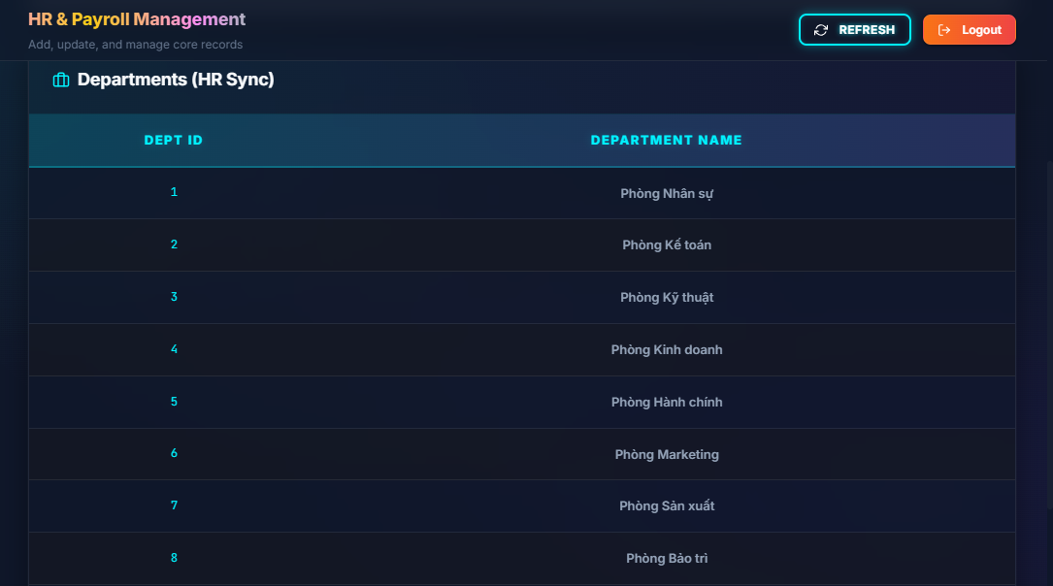
Figure 22: Departments
ID | Condition | Control Type | Target
1 | View | Section Title | Panel Header: Displays "Departments (HR Sync)" alongside a briefcase icon.
2 | View | Data Grid | Department Table: Displays the list of departments with two main columns: DEPT ID and DEPARTMENT NAME.
Table 23: Departments

3.7.7. Sub-Interface: Job Positions (HR Sync)
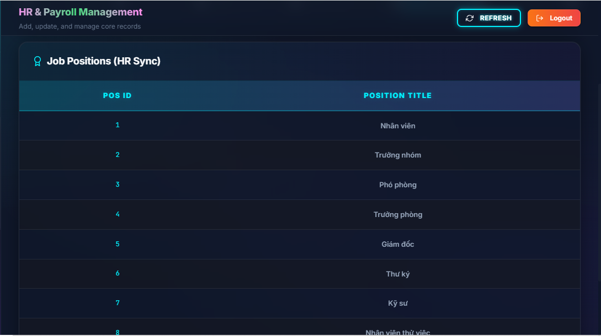
Figure 23: Job Positions
ID | Condition | Control Type | Target
1 | View | Section Title | Panel Header: Displays "Job Positions (HR Sync)" alongside a ribbon badge icon.
2 | View | Data Grid | Position Table: Lists the job titles within the organization with corresponding columns: POS ID and POSITION TITLE.
Table 24: Job Positions

3.7.8. Sub-Interface: Dividend Distributions
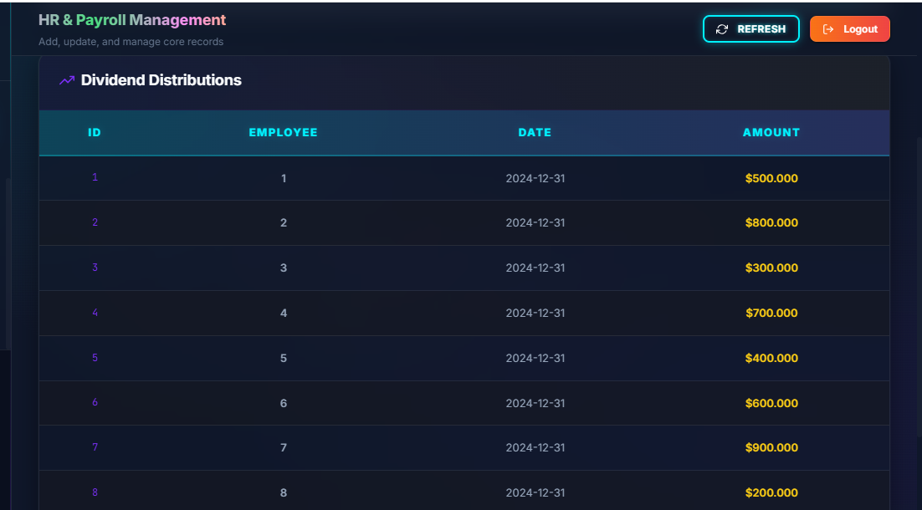
Figure 24: Dividend Distributions
ID | Condition | Control Type | Target
1 | View | Section Title | Panel Header: Displays "Dividend Distributions" along with an upward trending chart icon.
2 | View | Data Grid | Dividend Table: Provides detailed information through the columns: ID, EMPLOYEE, DATE, and AMOUNT.
3 | View | Text (Colored) | Financial Formatting: The data in the AMOUNT column is bolded and colored yellow to highlight cash flow information for administrators.
Table 25: Dividend Distributions

3.8. UI-08: API Explorer
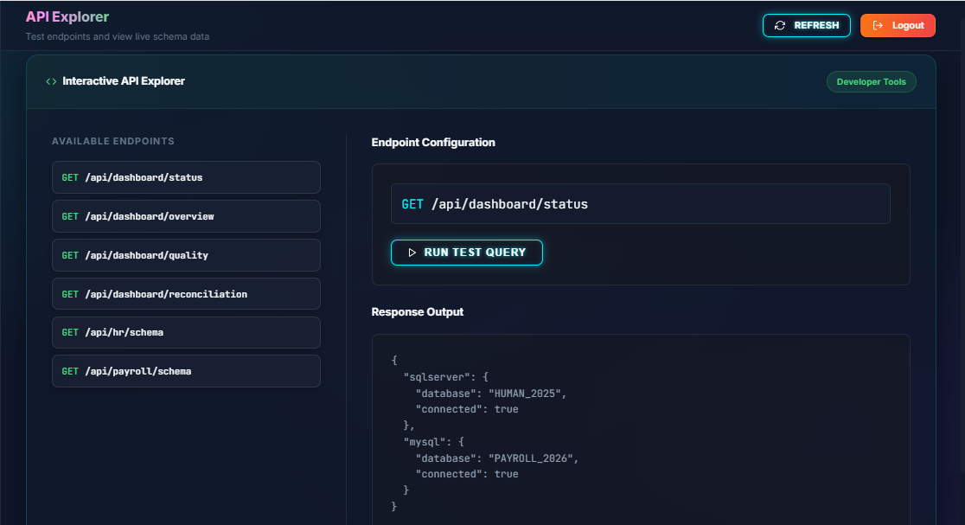
Figure 25: API Explorer
ID | Condition | Control Type | Target
1 | View | Text & Buttons | Page Header: Displays the title "API Explorer", the subtitle "Test endpoints and view live schema data", and global action buttons ("REFRESH" and "Logout").
2 | View | Section Panel | Interactive API Explorer: The main workspace container, marked with a "Developer Tools" badge to distinguish it from standard management functions.
3 | Press | Navigation List | AVAILABLE ENDPOINTS: The left sidebar listing clickable API methods (e.g., GET /api/dashboard/status). Users select an endpoint to load its configuration.
4 | View | Configuration Block | Endpoint Configuration: Displays the selected endpoint's HTTP method (GET) and its specific URL path.
5 | Press | Action Button | RUN TEST QUERY: A button with a Play icon used to execute the request against the configured endpoint.
6 | View | Code Block | Response Output: A panel that renders the server's response in a formatted JSON structure (e.g., displaying connectivity status for HUMAN_2025 and PAYROLL_2026).
Table 26: API Explorer

3.9. UI-09: Settings
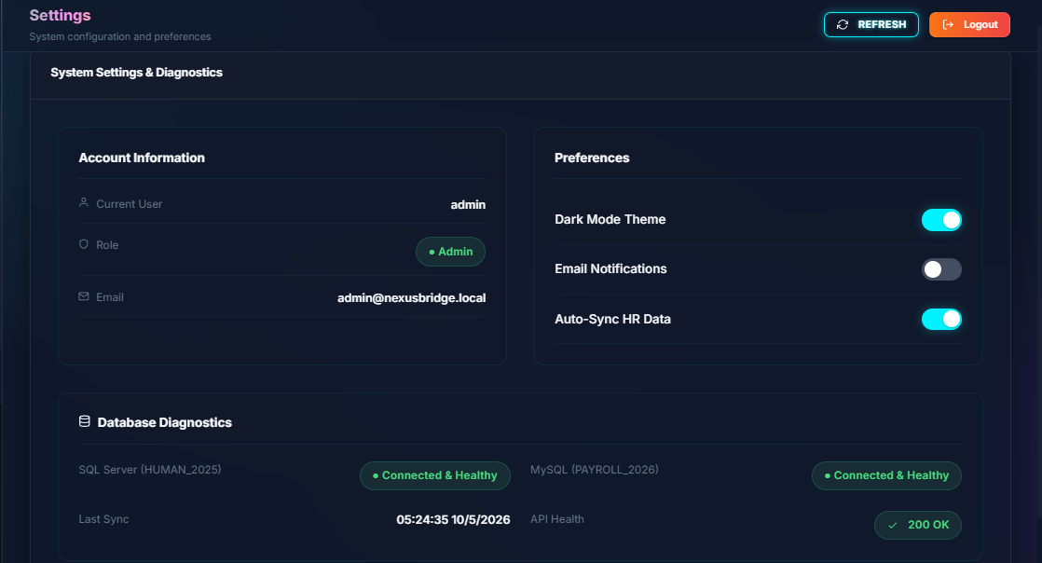
Figure 26: Settings
ID | Condition | Control Type | Target
1 | View | Text & Buttons | Page Header: Displays the title "Settings", the subtitle "System configuration and preferences", and the global "REFRESH" and "Logout" buttons.
2 | View | Section Panel | Account Information: A read-only card displaying the logged-in user's details, including "Current User", an assigned "Role" badge (e.g., Admin), and the registered "Email" address.
3 | Press | Toggle Switch | Dark Mode Theme: A switch to enable or disable the system's dark visual theme (indicated by a cyan toggle when active).
4 | Press | Toggle Switch | Email Notifications: A switch to turn automated system email alerts on or off.
5 | Press | Toggle Switch | Auto-Sync HR Data: A switch to enable or disable the automatic background synchronization of data between the HR and Payroll databases.
6 | View | Status Badge | SQL Server Diagnostics: Displays the live connection status for the HUMAN_2025 database (e.g., "Connected & Healthy" in green).
7 | View | Status Badge | MySQL Diagnostics: Displays the live connection status for the PAYROLL_2026 database (e.g., "Connected & Healthy" in green).
8 | View | Text & Badge | System Health Stats: Displays the exact timestamp of the "Last Sync" and an "API Health" indicator badge (e.g., "200 OK").
Table 27: Settings

3.10. UI-10: Account Management (Access Control)
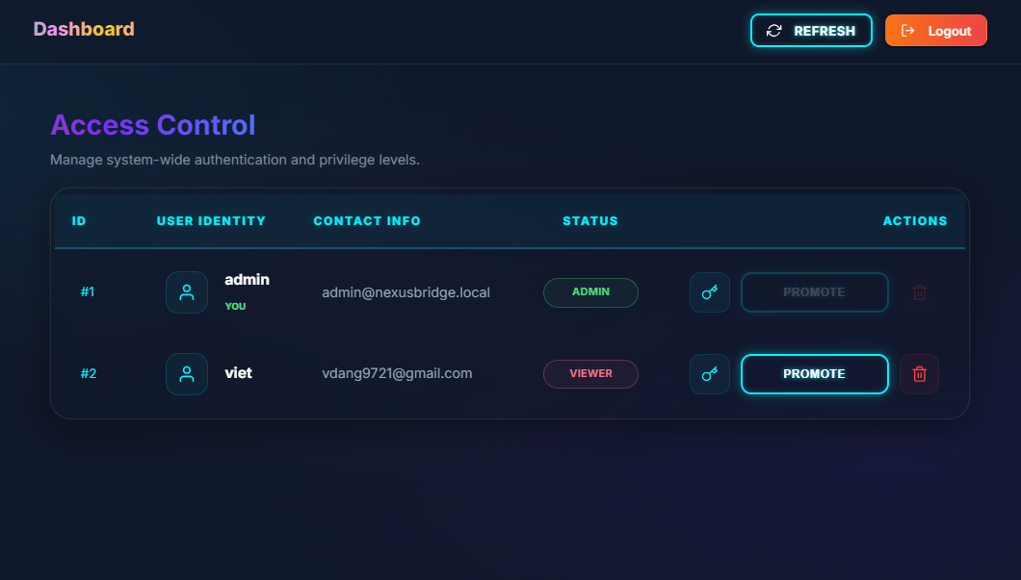
Figure 27: Account Management
ID | Condition | Control Type | Target
1 | View | Text | Page Title: Displays "Access Control" and the subtitle "Manage system-wide authentication and privilege levels.".
2 | View | Data Grid | User Table: A comprehensive table listing accounts with columns: ID, USER IDENTITY, CONTACT INFO, STATUS, and ACTIONS.
3 | View | User Identity | Profile Info: Displays the user's avatar, username, and email address. The active logged-in user is highlighted with a green "YOU" badge.
4 | View | Status Badge | Role Indicator: Displays the user's current permission level (e.g., ADMIN in green, VIEWER in red).
5 | Press | Action Icon | Reset Password: A key icon button that triggers the Security Reset modal.
6 | Press | Button (Action) | Promote: A primary action button used to elevate a user's role. This button is disabled/darkened for users who are already Administrators.
7 | Press | Action Icon | Delete/Revoke: A red trash icon to delete the user account.
Table 28: Account Management

3.10.1. Sub-Interface: Security Reset Modal
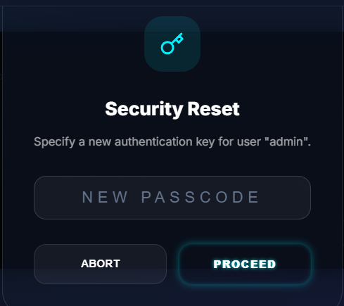
Figure 28: Security Reset Modal
ID | Condition | Control Type | Target
1 | View | Icon & Text | Modal Header: Displays a cyan key icon and the title "Security Reset".
2 | View | Text | Prompt Message: Instructs the admin to "Specify a new authentication key for user [username].".
3 | Press | Input (Password) | NEW PASSCODE: A secure text field to enter the new password string.
4 | Press | Button (Secondary) | ABORT: Cancels the operation and closes the modal without saving.
5 | Press | Button (Primary) | PROCEED: Submits the new passcode to the system database.
Table 29: Security Reset Modal

3.10.2. Sub-Interface: Role Update Modal
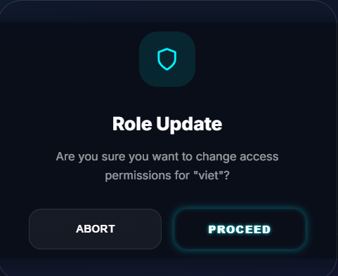
Figure 29: Role Update Modal
ID | Condition | Control Type | Target
1 | View | Icon & Text | Modal Header: Displays a cyan shield icon and the title "Role Update".
2 | View | Text | Warning Message: Asks the administrator "Are you sure you want to change access permissions for [username]?" to prevent accidental role changes.
3 | Press | Button (Secondary) | ABORT: Cancels the promotion process and closes the modal.
4 | Press | Button (Primary) | PROCEED: Confirms the action and updates the user's access rights in the system.
Table 30: Role Update Modal

